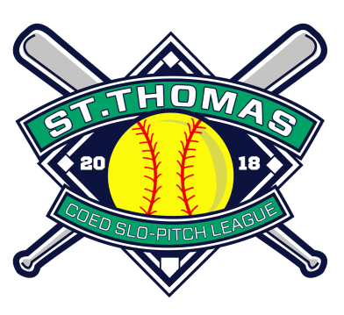

St. Thomas COED Slo-Pitch League Sponsorship and Advertising Packages
The 2018 COED Slo-Pitch season will begin on May 6th and over the next 4 months, every Sunday, 40 teams, each carrying a roster of 26 players along with friends and family will head to the Doug Tarry Sports Complex. In addition to 280 regular season games, our league hosts a pair of 2-Day Tournaments in June and August that will feature an additional 192 games played over 4 days. Our league offers a unique opportunity to reach a wide range of prospective local customers to let them know what your business has to offer. Listed below are different advertising opportunities that we are offering this season. Spots are limited and will be filled on a first come, first serve basis. For more information please contact: Scott Johnson via email scottiej86@hotmail.com
- Schedule Booklet Ad

- 600 Schedule Booklets are printed and distributed to League members
- Full Colour Ad
- Premade Ad can be submitted or
- Price includes ad design fee if needed
Price: Full Page $150 or Half Page $75
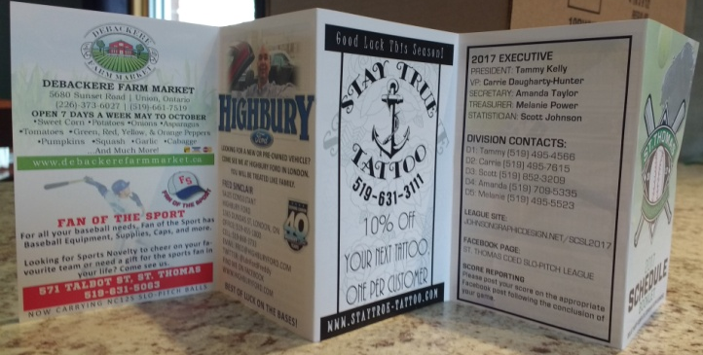
Examples:

- League Website Banner Ad

- Exposure to over 8000 site visitors between May and August
- Full Colour Banner Ad
- Linked to your own Website or Social Media page
- Premade Banner Ad can be submitted or
- Price includes ad design fee if needed
Price: $75
Examples:

- Tournament Sponsor (2 Tournaments, 4 Days)

- Mid-Season Tournament June 16-17 & Championship Tournament August 25-26
- Exposure to 40 Teams (roughly 500 players) and families over 4 days
- Exposure to over 650 Facebook League Members
- Company Name and Logo will be displayed on all Facebook Tournament Graphics
- Name, Logo, and Contact Info displayed on Sponsorship Graphic on Facebook page
- Company Name and Logo will be posted on the Tournament Schedule and Standings Board at the Doug Tarry Sports Complex
- Sponsors will be able to provide additional advertising in the form of Business cards, Pamphlets, Brochures, or other Print Ads that can be posted on the Tournament Board
Price: $200
- Complete League Sponsorship Package

- Half Page Schedule Booklet Ad ($75)
- League Website Banner Ad ($75)
- Tournament Sponsor ($200)
Price: $300

